Introduction

3.3V regulator is needed to supply the following loads.
Table 1: 3,3V loads and their maximum consumption.
Load | MAX[mA] | Notes
RS485 | 83,5
MCU | 203
Ethernet PHY | 129
Current measurement | 84 | 8 devices 10,5 mA maximum
Total | 499,5 | mA

Switch mode power supply is used. Input voltage for the regulator is the 5V from upstream regulator.

Circuit design

AP61100Q is selected from Krakul library. It has been used before, it can supply up to 1A and it’s efficient.
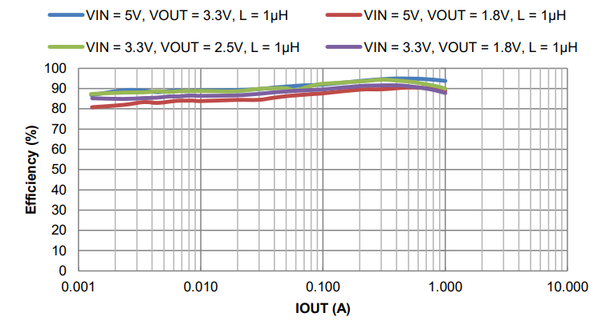
Figure 1: Efficiency of AP61100Q
Typical application circuit is followed.
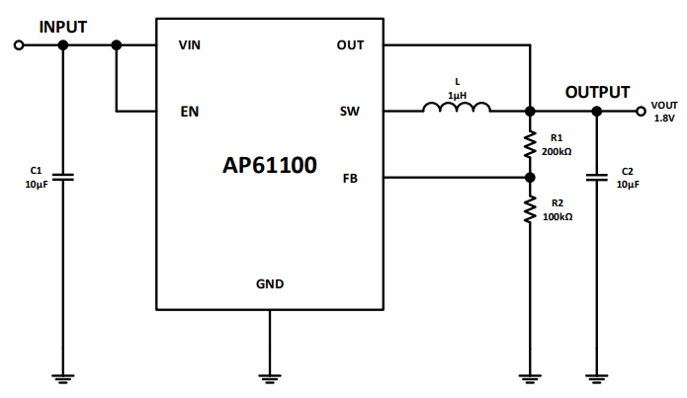
Figure 2: Typical application circuit
Recommended component values are used.
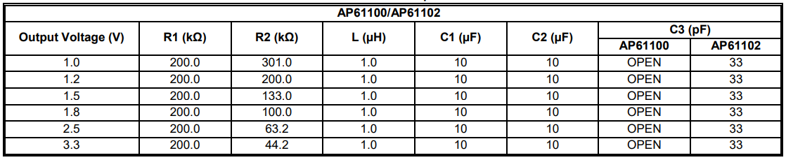
Figure 3: Recommended component values

100nF capacitors are added to input and output to further decouple high frequency switching noise.

0,001ms time constant RC filter made from 10kΩ and 100nF is added to the EN pin. This will delay regulator startup to help preventing it turning on before supply is stable.

